Linux Practical Examination
Section A — File & Directory Management
Q1. Basic File Operations • Create directory named LinuxExam.
- Navigate into the directory.
- Create: o student.txt o course.txt o result.txt
- Display the current working directory.
- Display the contents of the directory.
Ans :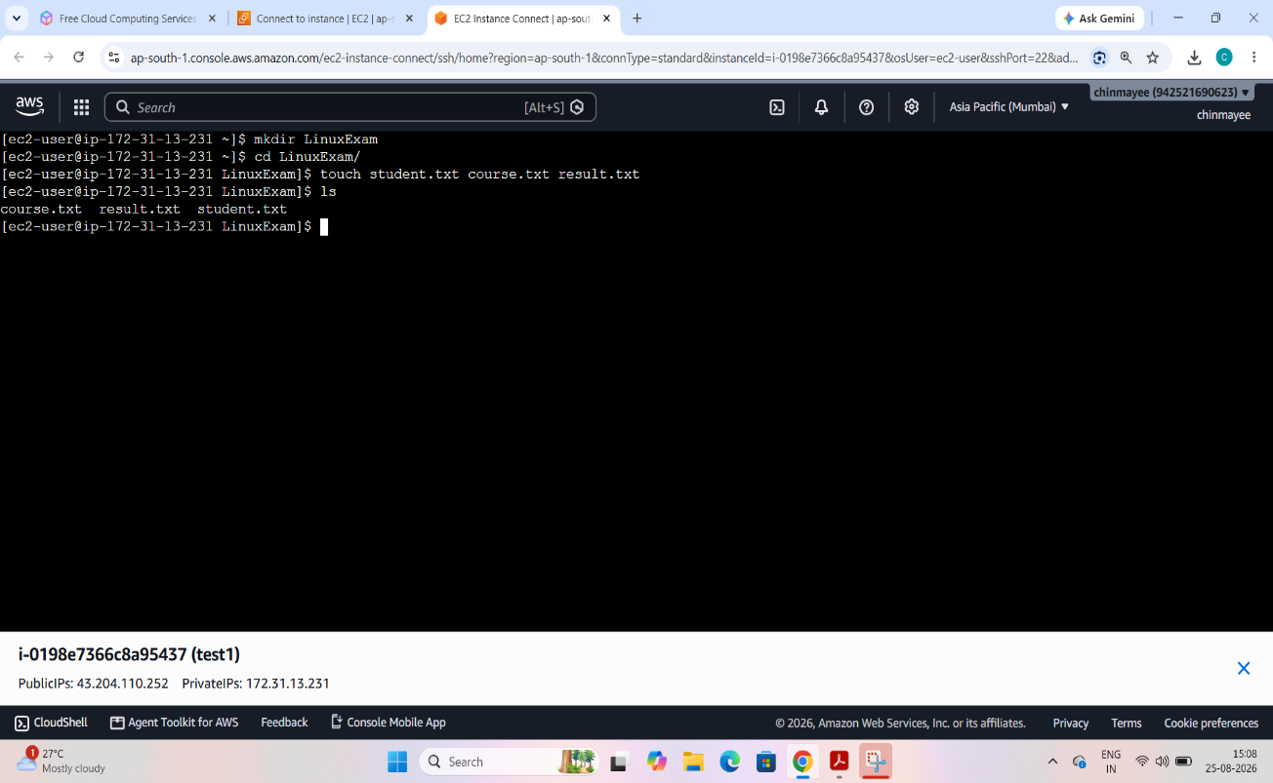
Q2. File Management Inside LinuxExam:
- Copy student.txt as student_backup.txt.
- Rename course.txt to linux_course.txt.
- Delete result.txt.
- Create directories: o Documents o Backups o Scripts
- Move student_backup.txt into Backups.
- Display the directory structure.
Ans: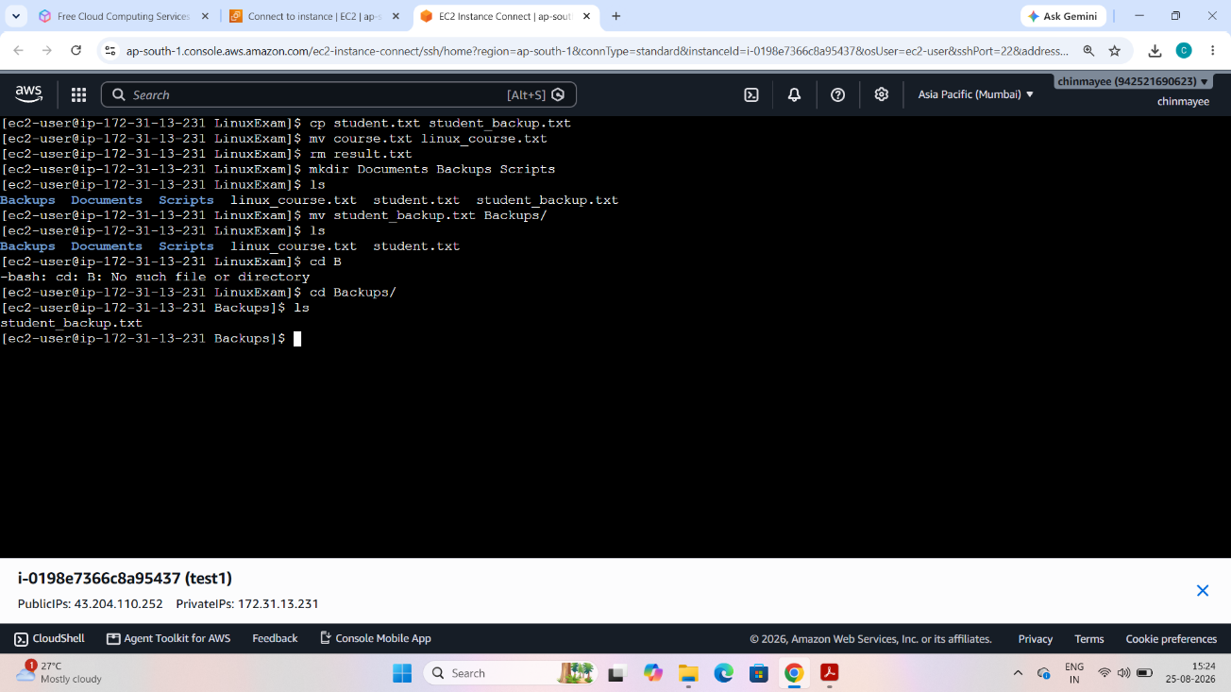
Q3. File Content Operations • Add at least 5 lines of student information to student.txt.
- Add at least 5 lines of course information to linux_course.txt. • Display the contents using cat.
- Display the first 3 lines using head.
- Display the last 2 lines using tail.
- Count the number of lines, words, and characters in student.tx
Ans: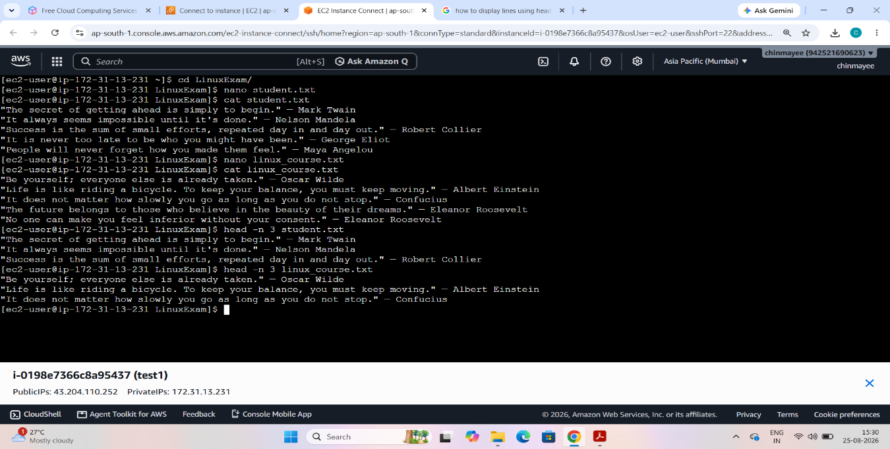
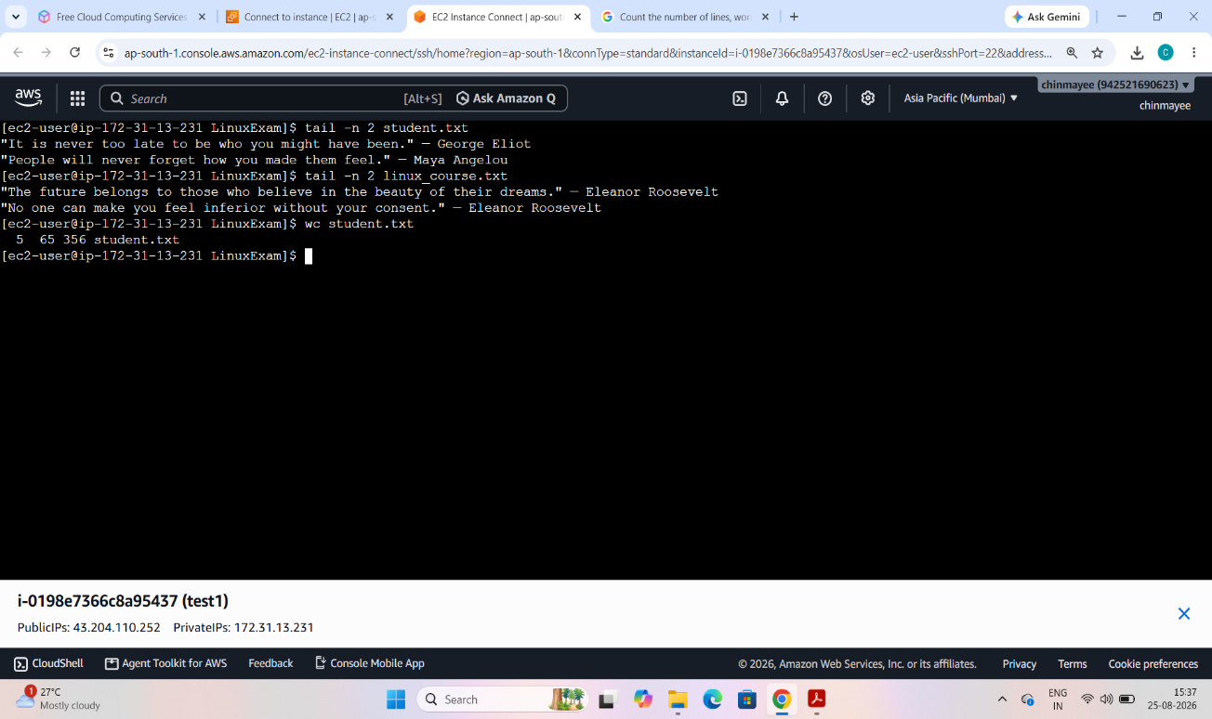

Section B — Users, Groups & Permissions
Q4. User Management
Create a user named student01.
- Set a password.
- Verify that the user exists.
- Display the user's UID and GID.
- Display the user's home directory.
- Switch to the student01 account and verify the current username.
Ans: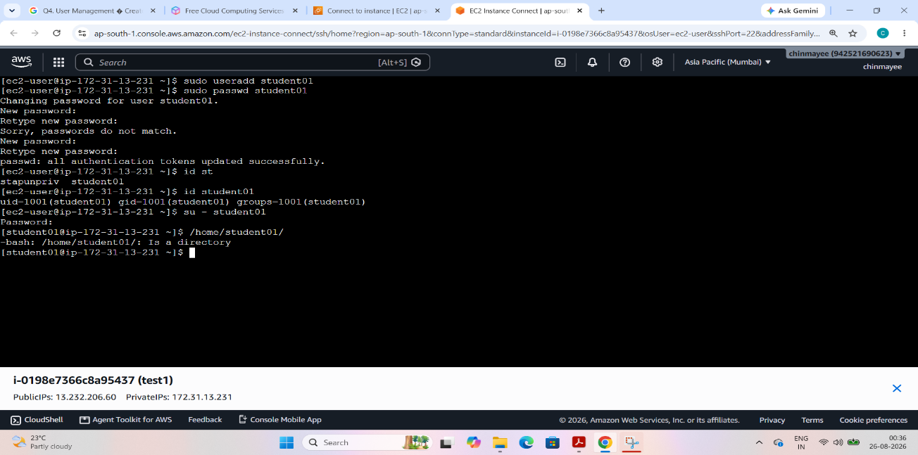
Q6. File Permissions
Create project.txt and:
- Give owner Read, Write and Execute permission.
- Give Group Read and Execute permission.
- Give Others Read permission only.
- Verify the permissions.
Expected: 754
- Change the permission to 640.
Ans: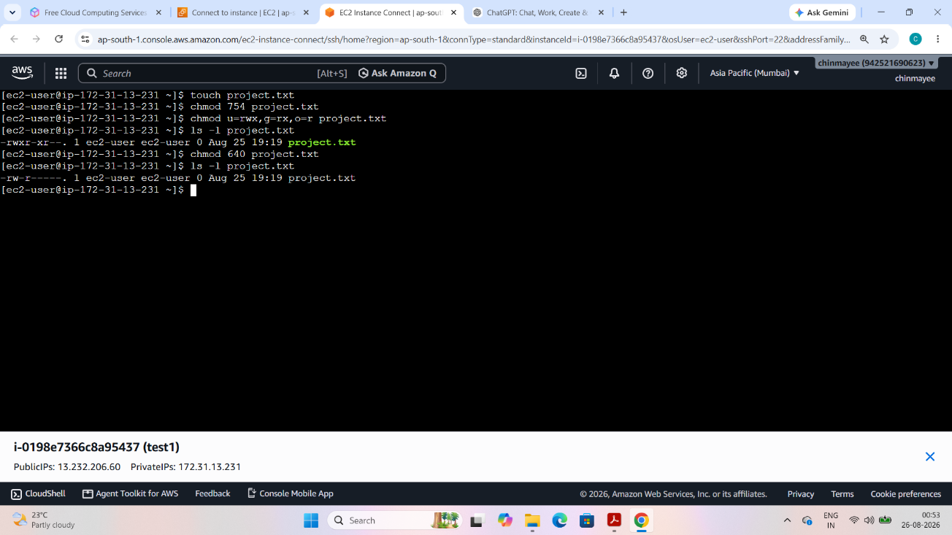
Q7. Permission Challenge Create:
LinuxExam/
├── public/
├── private/ └── shared/
Configure permissions so that:
- public can be accessed by everyone.
- private can be accessed only by its owner.
- shared can be accessed by the owner and group members. • Verify the permissions using ls -ld.
Ans: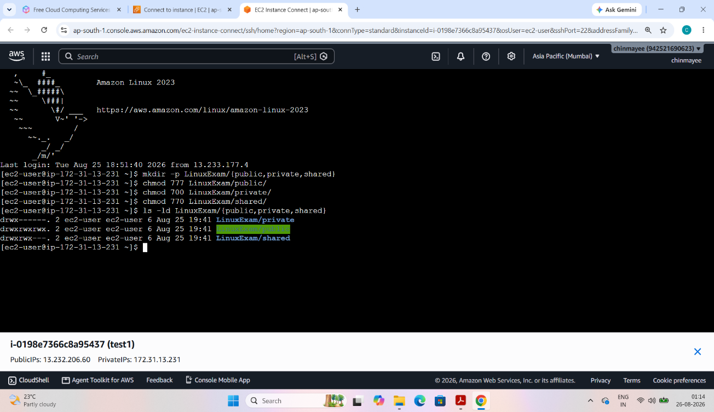

Section C — Package Management & Services
Q8. Package Management
- Update the package repository, Install Apache Web Server.
- Verify that Apache is installed, Display the installed Apache version.
- Start the Apache service, Check the status of Apache.
- Configure Apache to start automatically at boot.
Ans: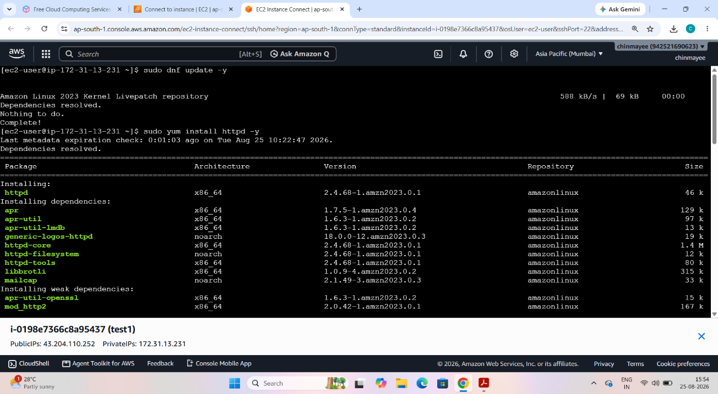
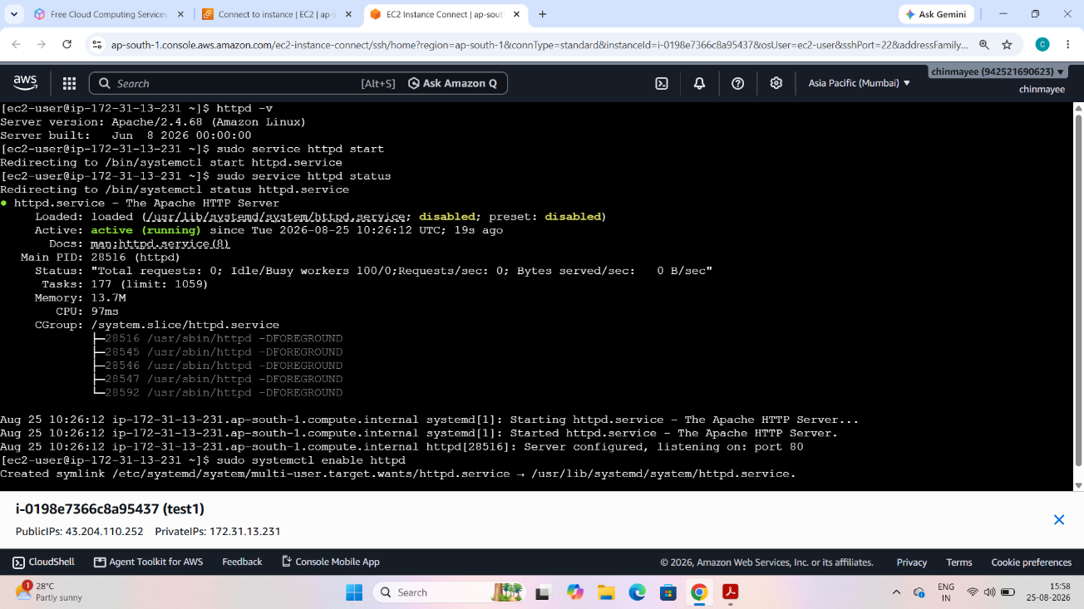
Q9. Apache Web Server Configuration
- Find the Apache document root, Create a custom index.html.
- Put the following information on the webpage:
- Student Name
o Roll Number o Course Name o "Linux Practical Examination"
• Start/restart Apache.
- Access the webpage using the browser or curl. • Display the HTTP response using curl.
Ans: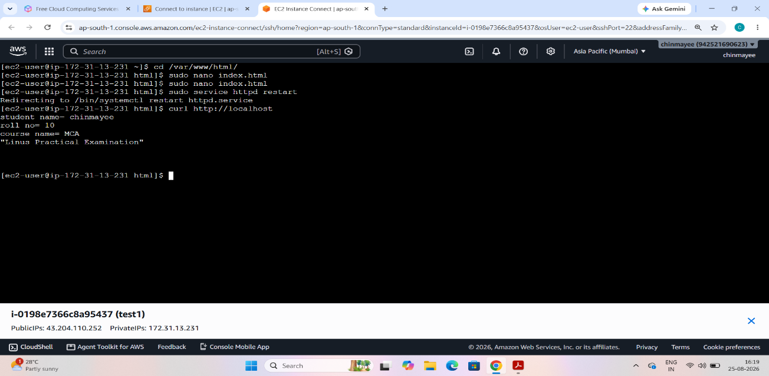
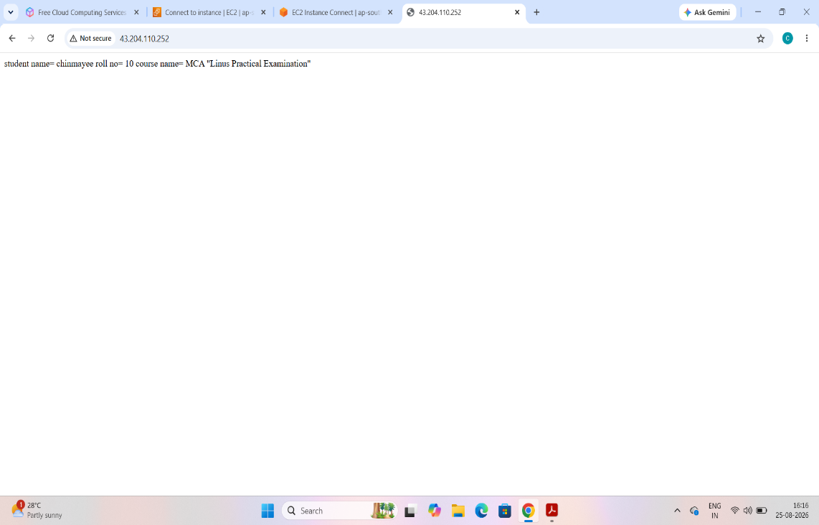

Section E — Searching, Filtering & Logs
Q11. Search and Text Processing
Inside LinuxExam:
- Create a file named students.txt containing at least 10 student records.
- Use grep to find students matching a specified name or pattern.
- Use grep with case-insensitive searching.
- Count matching records, Sort the student records.
- Search for a particular file using find.
Find all students whose name contains the letter a.or:
Find all .txt files inside the LinuxExam directory.
Ans: 